Architectural Design Document

**PREPARED FOR**

Niko Kuijpers

**PREPARED BY**

Maarten Blömer

Nick Krijgsman

Faruk Aydin

Jursley Gonzalez

Vincent Andersen

# 

# Table of Contents

**Table of Contents** **2**

**C4 Models** **3**

C1 3

C2 4

C3 5

C4 6

GasService 6

WindService 7

SunService 8

UserService 9

MeteoServer 10

MarketService 11

InvoiceService 12

RabbitConsumer 13

**Event Storming** **14**

# 

# C4 Models

## C1

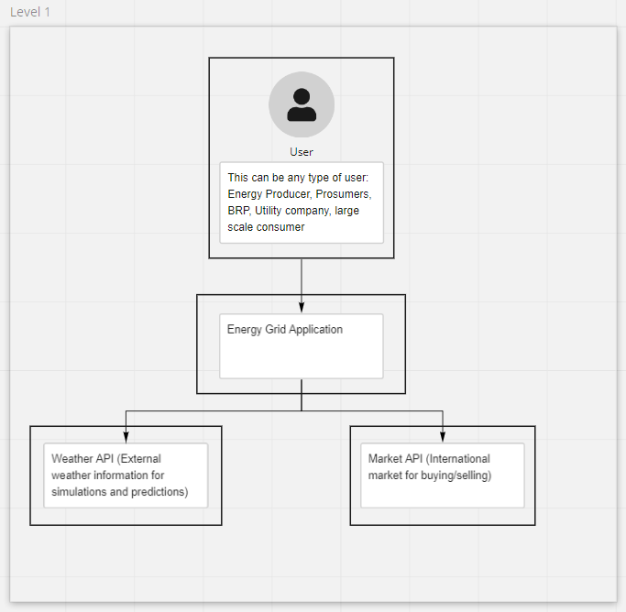

## C2

## 

## C3

## 

## C4

### GasService

([GasService](https://drive.google.com/file/d/1KXG0MJ9MxFujLvHAlc7lQAwNVQ0OwdxG/view?usp=sharing))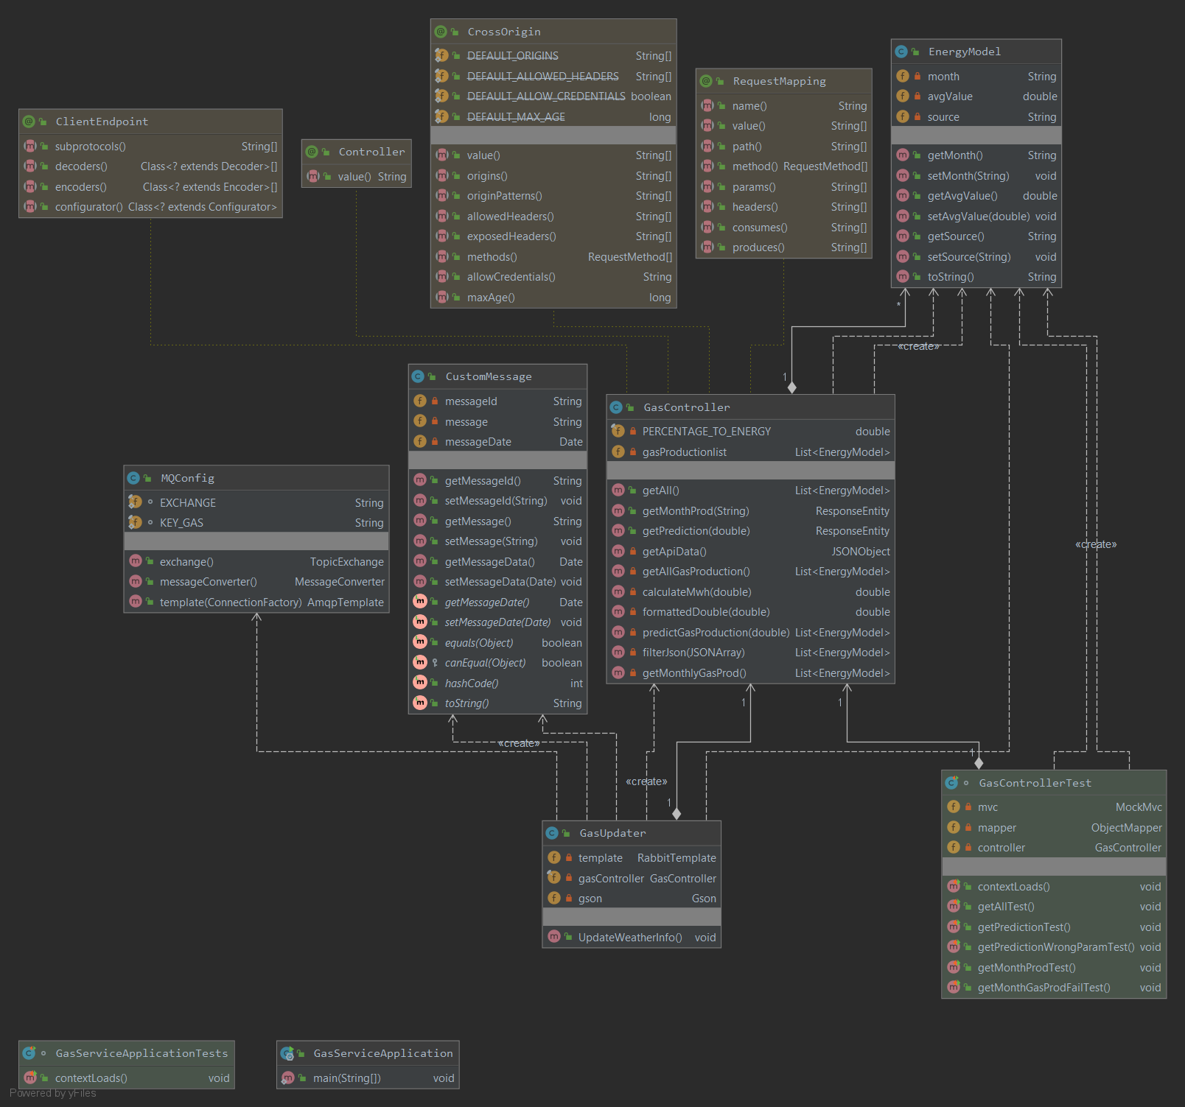

### WindService

([WindService](https://drive.google.com/file/d/16BgrAtP322eAbuQdz1yHgo80InwPkVHC/view?usp=sharing))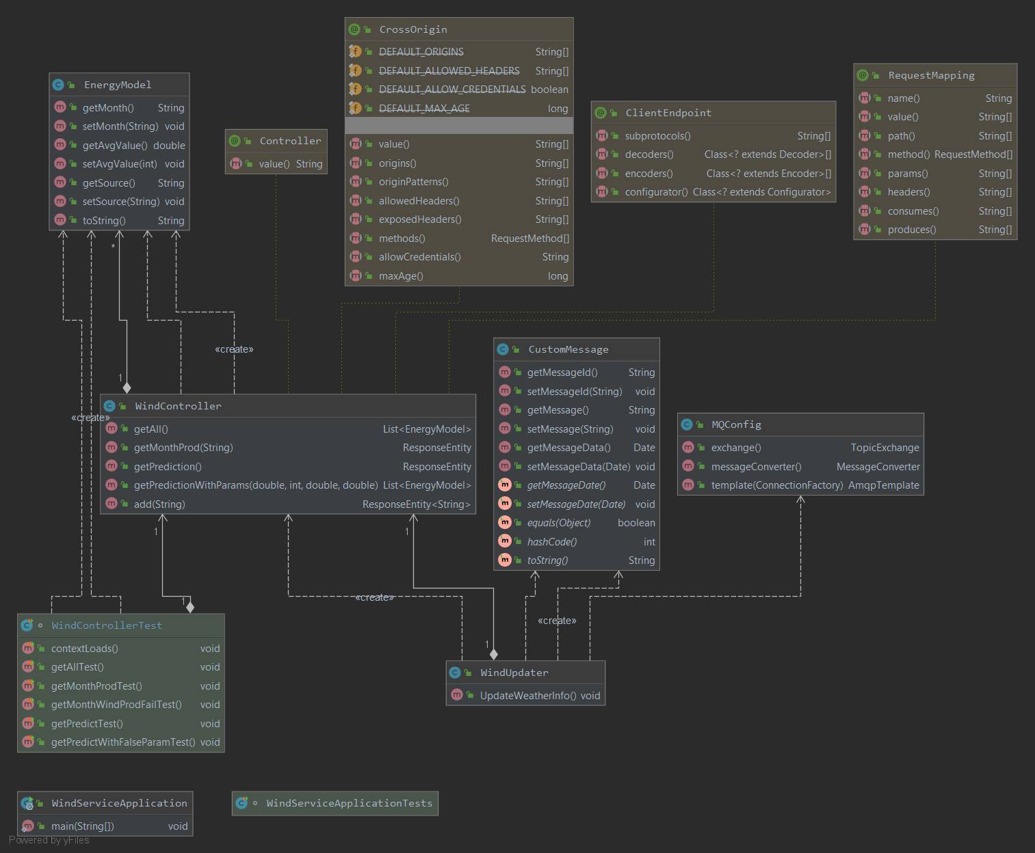

### SunService

([SunService](https://drive.google.com/file/d/1RHElSezDRlAEDVMmGXmAnnhHd408UOrO/view?usp=sharing))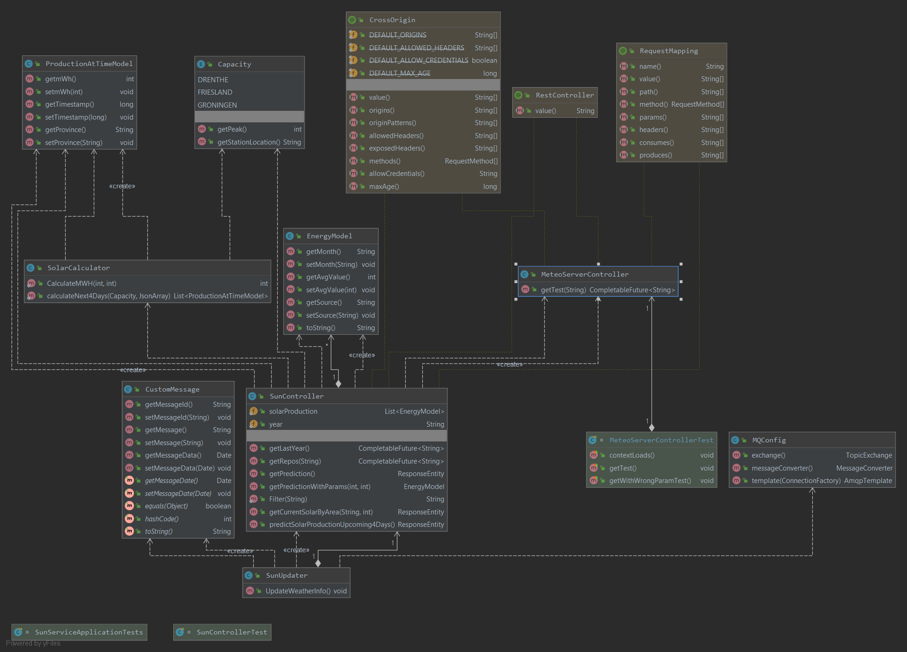

### UserService

([UserService](https://drive.google.com/file/d/1srPOdOpDp9nAPZYbE-L1auAymgyVPQ2c/view?usp=sharing))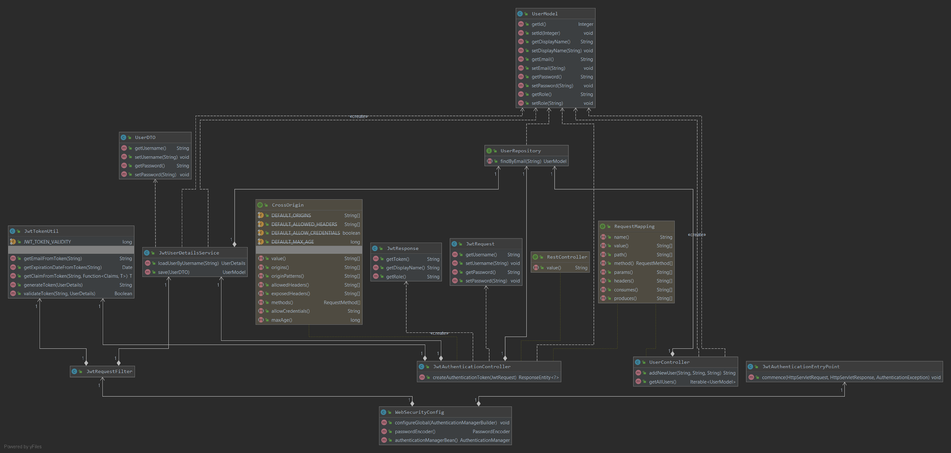

### MeteoServer

([MeteoServer](https://drive.google.com/file/d/15aw6YegRMiSaaWvg3MnLaC1uW2lOc01s/view?usp=sharing))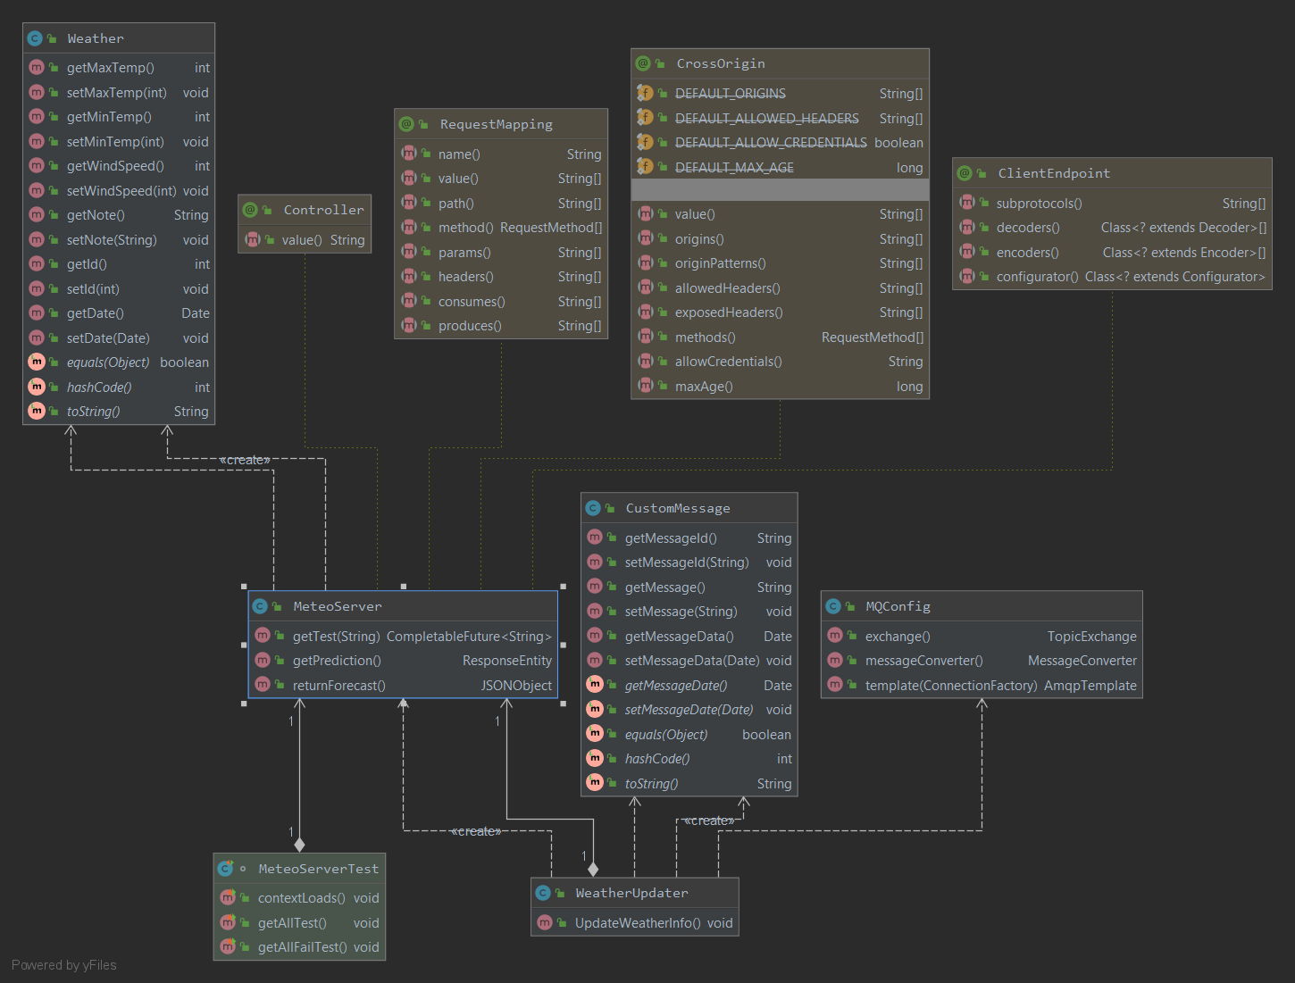

### MarketService

([MarketService](https://drive.google.com/file/d/1nwc5NO6SjZwjaU4QvWm7GSIkOczhTI_V/view?usp=sharing))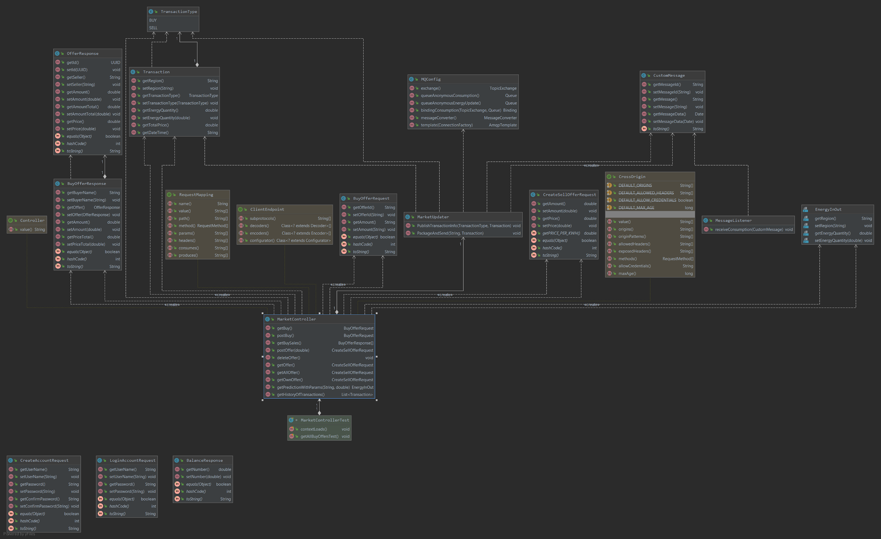

### InvoiceService

([InvoiceService](https://drive.google.com/file/d/1vRIt1ekKfeW47o1UdCYyiWI9mtvzJOEc/view?usp=sharing))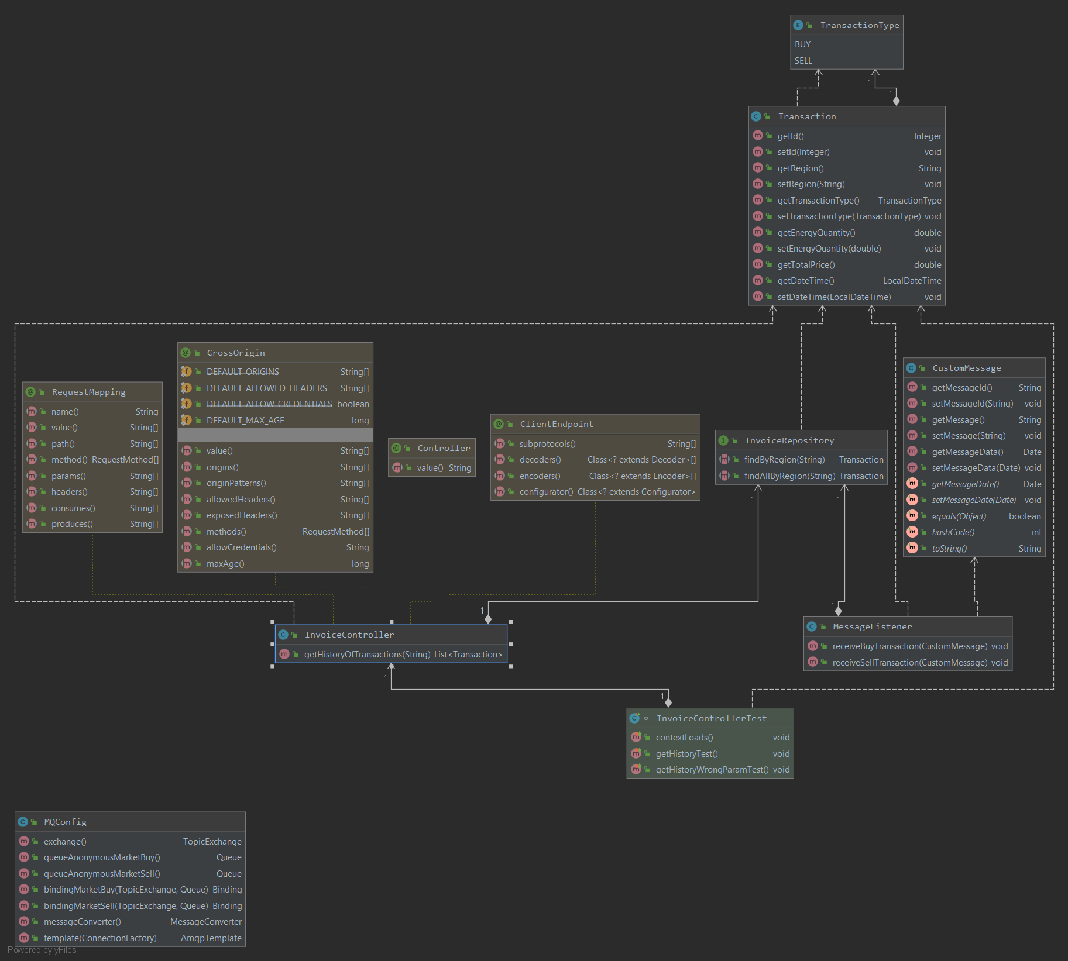

### RabbitConsumer

([RabbitConsumer](https://drive.google.com/file/d/1YCs86gQ2QAk_URASXqUb0VOTUu2Dt8ss/view?usp=sharing))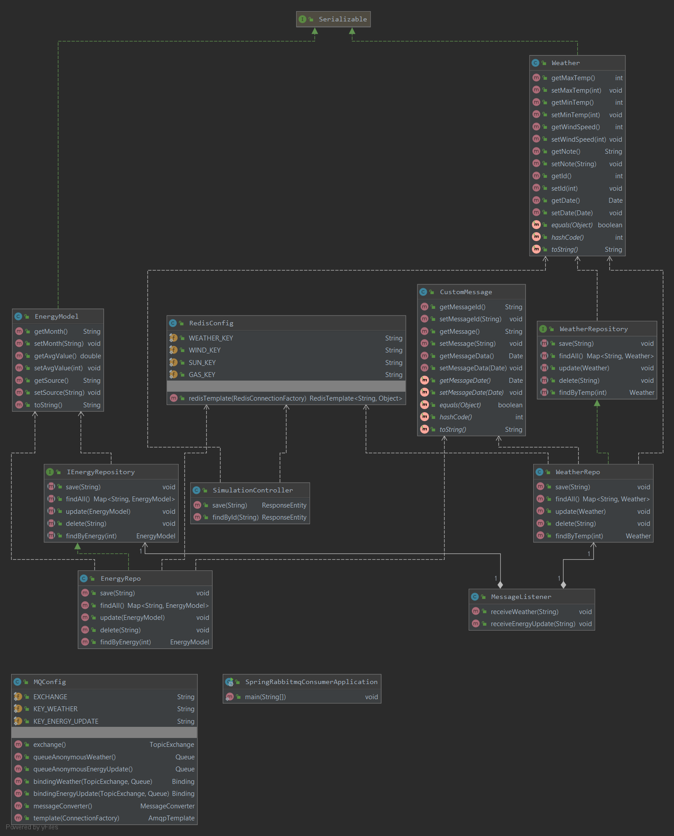

# Event Storming

